Requirements Engineering
Borrowing & Reservations Module
Library Management System
Author: Haris Kockici
Date: 03/04/2026

User Scenarios List
Short description of all the user scenarios for the Borrowing & Reservations module.

Nr | Role | Name | Description
US_01 | Member | Borrow a book | Member: Borrows a book from the library system so that they can read it for a limited borrowing period.
US_02 | Member | Check book availability | Member: Checks if a book is available before borrowing so that they know whether they can take it immediately.
US_03 | Member | Reserve a book | Member: Reserves a book that is currently borrowed by another user so that they can receive it when it becomes available.
US_04 | Member | Cancel reservation | Member: Cancels an active reservation so that other users can reserve the book if they no longer need it.
US_05 | Member | View borrowed books | Member: Views the list of currently borrowed books so that they can manage their reading and return deadlines.
US_06 | Librarian | Approve/reject borrowing requests | Librarian Staff: Approves or rejects borrowing requests so that library rules are followed.
US_07 | Librarian | Record book return | Librarian Staff: Records the return of a borrowed book so that the system updates book availability.
US_08 | Librarian | View active reservations | Librarian Staff: Views all active reservations so that they can manage the waiting list for books.
US_09 | Member | Receive availability notification | Member: Receives a notification when a reserved book becomes available so that they can borrow it quickly.
US_10 | Administrator | Define borrowing limits | Administrator: Defines borrowing limits (number of books and duration) so that the system follows library policies.

User Scenarios Extended
US_01: Borrow a book
1. Member navigates to the Book Catalog and selects an available book.
2. Member clicks 'Borrow' on the book detail page.
3. System checks book availability (AvailableCopies > 0).
4. System checks that the member has not exceeded their borrowing limit.
5. System creates a new BorrowingRecord with status 'Active' and calculates the due date.
6. System decrements AvailableCopies by 1.
7. Member receives a confirmation and can view the loan in their borrowed books list.
8. If no copies available: System displays 'No copies available' and offers reservation option.
9. If borrowing limit reached: System displays an error message with current limit details.

US_02: Check book availability
1. Member browses or searches the catalog.
2. Member opens a book detail page.
3. System retrieves current AvailableCopies and TotalCopies for the book.
4. System displays availability status: number of available copies, total copies, and due dates of borrowed copies.
5. If copies are available: 'Available' status shown with 'Borrow' button enabled.
6. If no copies available: 'Unavailable' status shown with 'Reserve' button offered.

US_03: Reserve a book
1. Member views a book with no available copies.
2. Member clicks 'Reserve' on the book detail page.
3. System checks if member already has an active reservation for this book.
4. System checks if member has not exceeded the reservation limit.
5. System creates a new ReservationRecord with status 'Pending' and timestamps.
6. Member is added to the waiting list in order of reservation time.
7. Member receives a confirmation with their queue position.
8. If member already has a reservation: System displays a duplicate warning.
9. If reservation limit reached: System displays an error message.

US_04: Cancel reservation
1. Member navigates to 'My Reservations' section.
2. Member selects the reservation they wish to cancel.
3. Member clicks 'Cancel Reservation'.
4. System prompts for confirmation.
5. Member confirms cancellation.
6. System sets reservation status to 'Cancelled'.
7. Waiting list is updated; subsequent members move up in queue.
8. If member cancels action: No changes are made.

US_05: View borrowed books
1. Member navigates to 'My Borrowings' section.
2. System retrieves all active BorrowingRecords for the logged-in member.
3. System displays the list with: book title, borrow date, due date, and status.
4. Overdue books are highlighted with a warning indicator.
5. Member can click a book to view full borrowing details.
6. If no active borrowings: System displays 'You have no active borrowings.'

US_06: Approve or reject borrowing requests
1. Librarian navigates to the 'Borrowing Requests' management panel.
2. System displays all pending borrowing requests with member details and book information.
3. Librarian reviews the request and clicks 'Approve' or 'Reject'.
4. If approved: System creates a BorrowingRecord, decrements AvailableCopies, and notifies the member.
5. If rejected: System updates request status to 'Rejected', and notifies the member with an optional reason.
6. If book is no longer available at approval time: System prevents approval and notifies the librarian.

US_07: Record book return
1. Librarian navigates to the 'Active Loans' section.
2. Librarian searches for the member or scans the book ISBN.
3. Librarian selects the corresponding BorrowingRecord and clicks 'Record Return'.
4. System sets the BorrowingRecord status to 'Returned' and records the return date.
5. System increments AvailableCopies by 1.
6. System checks if there are pending reservations for this book.
7. If reservations exist: System notifies the next member in the waiting list.
8. If book is returned after due date: System flags it as a late return for record-keeping.

US_08: View all active reservations
1. Librarian navigates to the 'Reservations' management panel.
2. System retrieves all active ReservationRecords with status 'Pending'.
3. System displays reservations with: book title, member name, reservation date, and queue position.
4. Librarian can filter by book title or member name.
5. Librarian can view full reservation details for any entry.
6. If no active reservations: System displays 'No active reservations at this time.'

US_09: Receive availability notification
1. A borrowed book is returned and AvailableCopies is incremented.
2. System checks the reservation waiting list for this book.
3. System identifies the member with the earliest pending reservation.
4. System sends a notification to the member (in-app and/or email) informing them the book is available.
5. Notification includes a direct link to borrow the book and a deadline to claim it.
6. Member opens the notification and is directed to the book detail page to complete the borrow.
7. If member does not borrow within the claim deadline: Reservation expires and the next member is notified.

US_10: Define borrowing limits
1. Administrator navigates to the 'Library Policy Settings' section.
2. System displays the current borrowing policy: max books per member and max borrowing duration (days).
3. Administrator updates the desired policy fields.
4. System validates the new values (must be positive integers within allowed range).
5. System saves the new policy settings and displays a confirmation message.
6. New limits are applied to all future borrowing requests immediately.
7. If invalid values entered: System shows field-level validation errors.

Use Cases
UC_01: Borrow a book
UC_01 — Borrow a book
UC Name | UC_01 — Borrow a book
Dependency | Book must exist and have AvailableCopies > 0. Member must be authenticated.
Actors | Primary actor: Member | Secondary actor: None
Preconditions | Member is logged in. Book exists with available copies. Member has not exceeded borrowing limit.
Description of the Main Sequence | 1. Member selects an available book from the catalog.  2. Member clicks 'Borrow'.  3. System validates availability and member borrowing limit.  4. System creates BorrowingRecord (status: Active) and calculates due date.  5. System decrements AvailableCopies by 1.  6. Member receives confirmation.
Description of the Alternative Sequence | • No copies available: 'No copies available' shown; reservation offered.  • Borrowing limit reached: Error message with current policy shown.
Non functional requirements | Borrowing operation must complete within 2 seconds. AvailableCopies must be updated atomically.
Postconditions | BorrowingRecord is created. AvailableCopies is decremented. Member can view loan in 'My Borrowings'.

UC_02: Check book availability
UC_02 — Check book availability
UC Name | UC_02 — Check book availability
Dependency | None
Actors | Primary actor: Member | Secondary actor: None
Preconditions | Book exists and is active in the catalog.
Description of the Main Sequence | 1. Member navigates to or searches for a book.  2. Member opens the book detail page.  3. System retrieves and displays AvailableCopies and TotalCopies.  4. System shows availability status and relevant action button (Borrow or Reserve).
Description of the Alternative Sequence | • Book unavailable: 'No copies available' status shown; 'Reserve' button offered.
Non functional requirements | Availability data must be real-time accurate. Page must load within 1.5 seconds.
Postconditions | Member is informed of current book availability status.

UC_03: Reserve a book
UC_03 — Reserve a book
UC Name | UC_03 — Reserve a book
Dependency | Book must exist. Member must be authenticated.
Actors | Primary actor: Member | Secondary actor: None
Preconditions | Member is logged in. Book has no available copies. Member has no existing reservation for this book.
Description of the Main Sequence | 1. Member clicks 'Reserve' on a book detail page.  2. System validates no duplicate reservation exists and reservation limit not exceeded.  3. System creates a ReservationRecord with status 'Pending'.  4. Member is added to the waiting list with timestamp.  5. Member receives confirmation with queue position.
Description of the Alternative Sequence | • Member already has reservation: Duplicate warning shown.  • Reservation limit reached: Error message shown.
Non functional requirements | Reservation creation must complete within 2 seconds. Queue position must be accurate.
Postconditions | ReservationRecord created. Member is in the waiting list.

UC_04: Cancel reservation
UC_04 — Cancel reservation
UC Name | UC_04 — Cancel reservation
Dependency | UC_03 — active reservation must exist
Actors | Primary actor: Member | Secondary actor: None
Preconditions | Member is logged in. Member has an active reservation for the book.
Description of the Main Sequence | 1. Member navigates to 'My Reservations'.  2. Member selects a reservation and clicks 'Cancel'.  3. System prompts for confirmation.  4. Member confirms.  5. System sets reservation status to 'Cancelled'.  6. Waiting list queue is updated for subsequent members.
Description of the Alternative Sequence | • Member cancels action: No changes made.
Non functional requirements | Queue must be updated in real-time after cancellation.
Postconditions | Reservation is marked 'Cancelled'. Waiting list is reordered.

UC_05: View borrowed books
UC_05 — View borrowed books
UC Name | UC_05 — View borrowed books
Dependency | UC_01 — at least one borrowing must exist
Actors | Primary actor: Member | Secondary actor: None
Preconditions | Member is logged in.
Description of the Main Sequence | 1. Member navigates to 'My Borrowings'.  2. System retrieves all active BorrowingRecords for the member.  3. System displays title, borrow date, due date, and status.  4. Overdue books are highlighted.  5. Member can click any entry for full details.
Description of the Alternative Sequence | • No active borrowings: 'You have no active borrowings' displayed.
Non functional requirements | List must load within 1.5 seconds. Overdue items must be visually distinct.
Postconditions | Member has full view of their current borrowings and deadlines.

UC_06: Approve or reject borrowing requests
UC_06 — Approve or reject borrowing requests
UC Name | UC_06 — Approve or reject borrowing requests
Dependency | Member must have submitted a borrowing request.
Actors | Primary actor: Librarian Staff | Secondary actor: None
Preconditions | Librarian is logged in. At least one borrowing request is pending.
Description of the Main Sequence | 1. Librarian navigates to 'Borrowing Requests' panel.  2. Librarian reviews requests and clicks 'Approve' or 'Reject'.  3. If approved: System creates BorrowingRecord, decrements copies, notifies member.  4. If rejected: System sets request to 'Rejected', notifies member with optional reason.
Description of the Alternative Sequence | • Book no longer available at approval time: Approval prevented; librarian notified.
Non functional requirements | Approval/rejection must be processed within 2 seconds. Member notification sent immediately.
Postconditions | Borrowing request status updated. Member notified. Availability updated if approved.

UC_07: Record book return
UC_07 — Record book return
UC Name | UC_07 — Record book return
Dependency | UC_01 — active BorrowingRecord must exist
Actors | Primary actor: Librarian Staff | Secondary actor: None
Preconditions | Librarian is logged in. Active BorrowingRecord exists for the book and member.
Description of the Main Sequence | 1. Librarian searches for the loan by member name or book ISBN.  2. Librarian selects the BorrowingRecord and clicks 'Record Return'.  3. System sets status to 'Returned' and records return date.  4. System increments AvailableCopies by 1.  5. System checks for pending reservations.  6. If reservations exist: Next member in queue is notified.
Description of the Alternative Sequence | • Book returned after due date: Late return flagged in system records.
Non functional requirements | Return operation must complete within 2 seconds. AvailableCopies updated atomically.
Postconditions | BorrowingRecord closed. Book availability restored. Reservation queue notified if applicable.

UC_08: View all active reservations
UC_08 — View all active reservations
UC Name | UC_08 — View all active reservations
Dependency | At least one active ReservationRecord must exist
Actors | Primary actor: Librarian Staff | Secondary actor: None
Preconditions | Librarian is logged in.
Description of the Main Sequence | 1. Librarian navigates to 'Reservations' management panel.  2. System retrieves all ReservationRecords with status 'Pending'.  3. System displays: book title, member name, reservation date, queue position.  4. Librarian can filter by book or member name.  5. Librarian can view full reservation details.
Description of the Alternative Sequence | • No active reservations: 'No active reservations' message displayed.
Non functional requirements | List must load within 2 seconds. Filter must be case-insensitive and real-time.
Postconditions | Librarian has full visibility of the reservation waiting list.

UC_09: Receive availability notification
UC_09 — Receive availability notification
UC Name | UC_09 — Receive availability notification
Dependency | UC_03 — active reservation must exist; UC_07 — book must be returned
Actors | Primary actor: Member | Secondary actor: Notification Service
Preconditions | Book has been returned. Member has an active reservation for the book.
Description of the Main Sequence | 1. System detects AvailableCopies > 0 after a return.  2. System identifies the member with earliest pending reservation.  3. System sends in-app and/or email notification to the member.  4. Notification includes a borrow link and claim deadline.  5. Member clicks notification and borrows the book.
Description of the Alternative Sequence | • Member does not claim within deadline: Reservation expires; next member in queue notified.
Non functional requirements | Notification must be sent within 60 seconds of the return event. Claim deadline must be configurable by administrator.
Postconditions | Member is notified. Book can be claimed by the first member in the queue.

UC_10: Define borrowing limits
UC_10 — Define borrowing limits
UC Name | UC_10 — Define borrowing limits
Dependency | None
Actors | Primary actor: Administrator | Secondary actor: None
Preconditions | Administrator is logged in.
Description of the Main Sequence | 1. Administrator navigates to 'Library Policy Settings'.  2. System displays current policy: max books per member, max borrowing duration.  3. Administrator updates desired fields and saves.  4. System validates values (positive integers within allowed range).  5. System saves and applies new policy to all future borrowings.  6. Confirmation message is displayed.
Description of the Alternative Sequence | • Invalid values entered: Field-level validation errors shown.  • Administrator cancels: No changes made.
Non functional requirements | Policy changes must be applied immediately to new requests. Settings must be saved within 2 seconds.
Postconditions | New borrowing policy is active. All future requests enforce the updated limits.

Use Case Diagrams

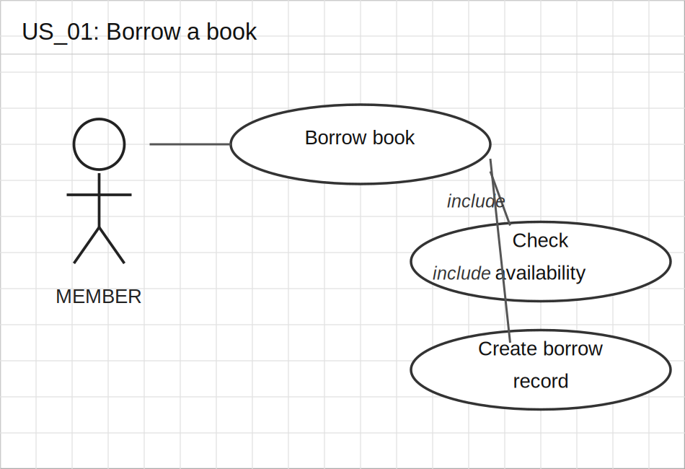 | 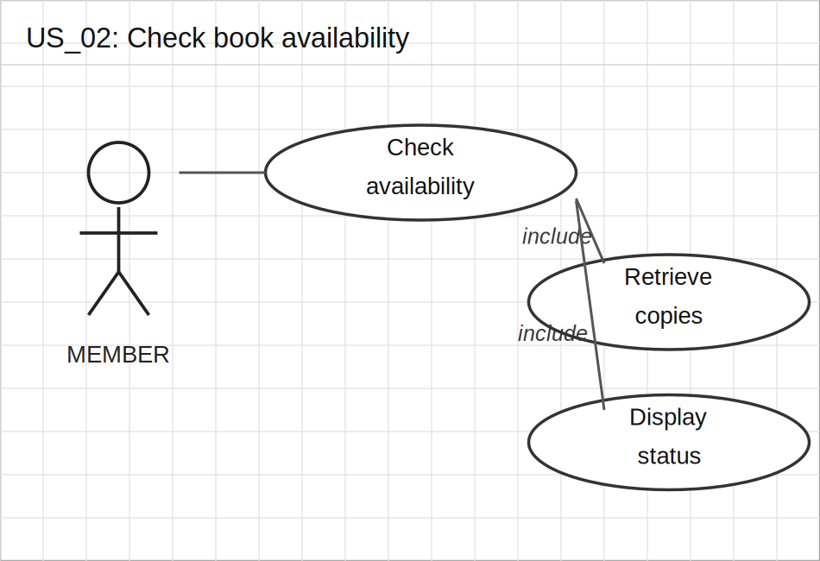
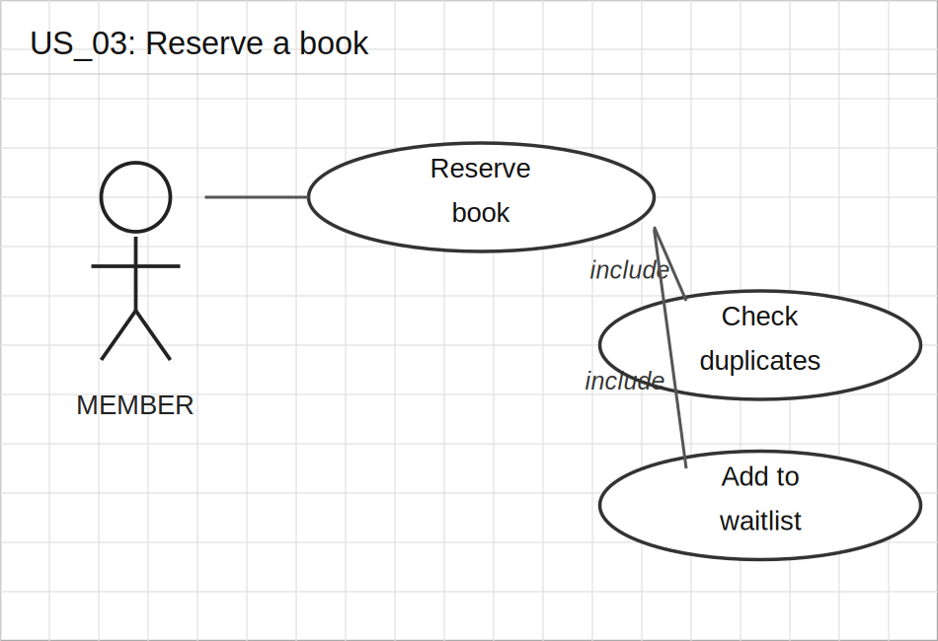 | 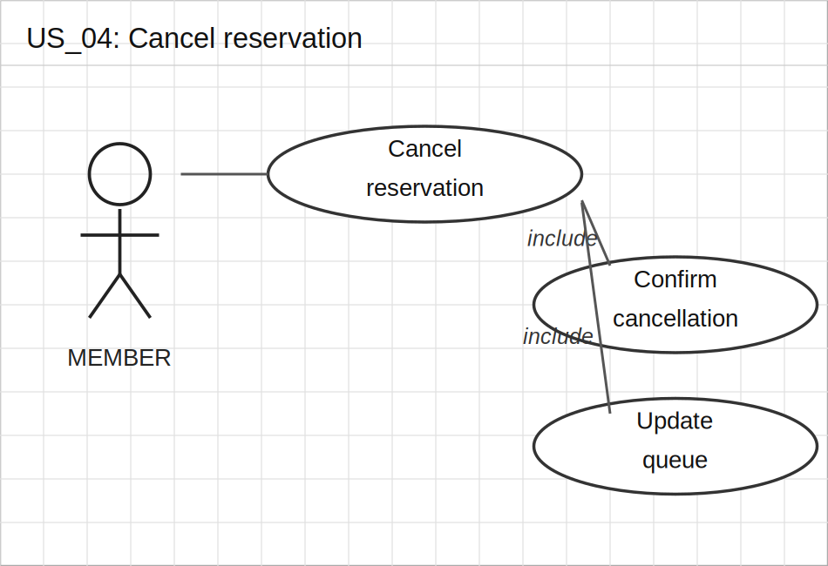
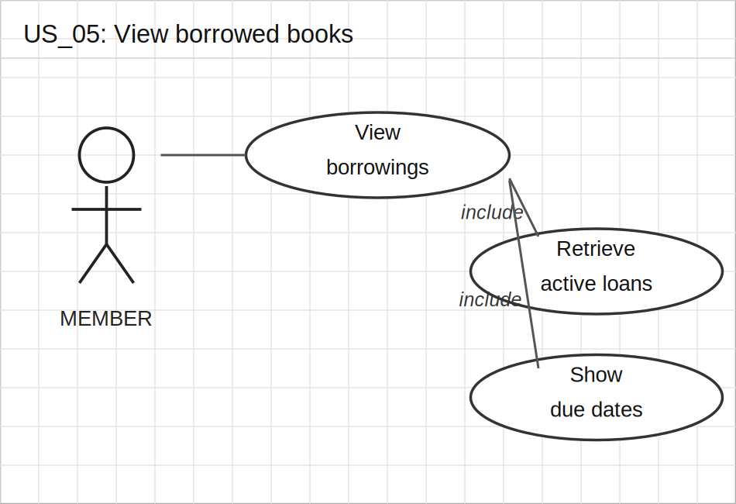 | 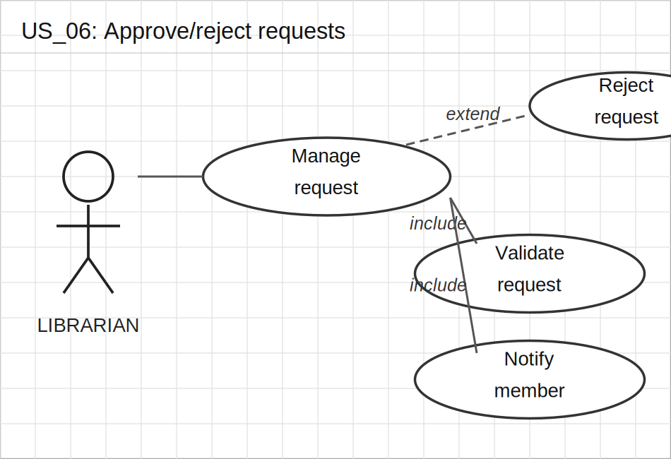
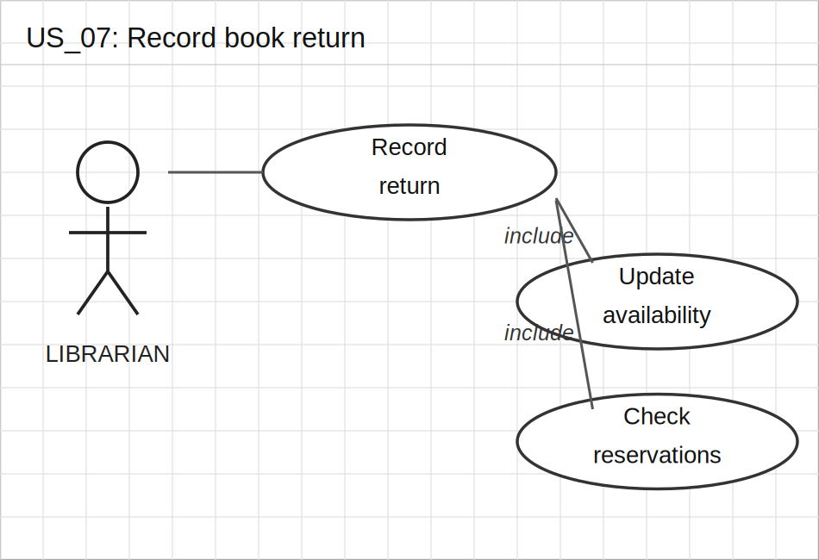 | 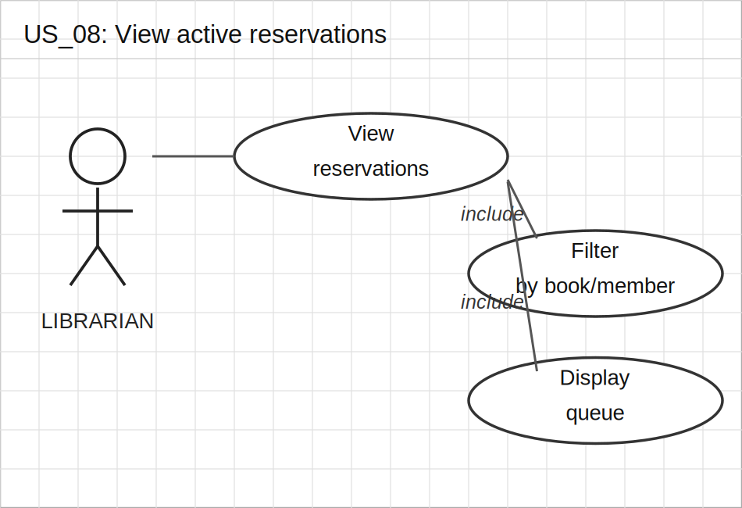
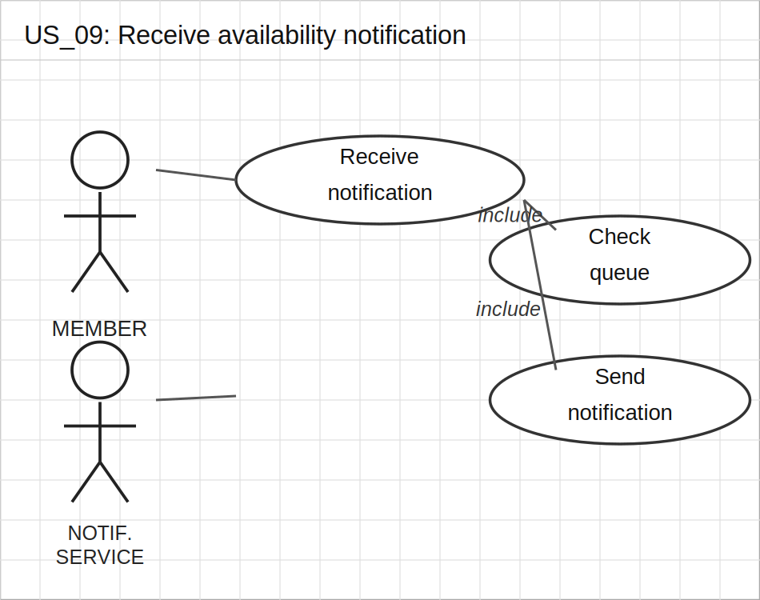 | 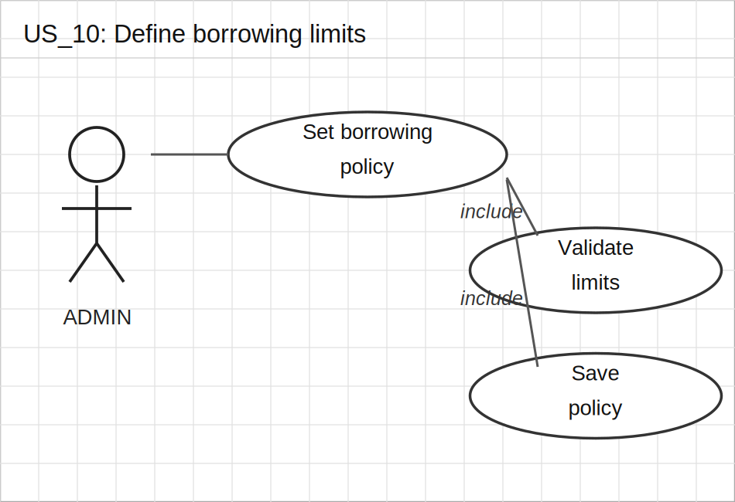

Functional Requirements

Req# | Role | Requirement | Comments | Priority | Date | Reviewed
FR_01 | Member | The system shall allow members to borrow a book, creating a BorrowingRecord with due date, provided copies are available and the member has not exceeded the borrowing limit. | Atomic decrement of AvailableCopies required. | 1 | 03/04/2026 | Haris Kockici
FR_02 | Member | The system shall display real-time availability status (available copies, total copies) on each book detail page. | Page must load within 1.5 seconds. | 1 | 03/04/2026 | Haris Kockici
FR_03 | Member | The system shall allow members to reserve a book with no available copies, adding them to a waiting list ordered by reservation timestamp. | Duplicate reservations per member per book must be prevented. | 1 | 03/04/2026 | Haris Kockici
FR_04 | Member | The system shall allow members to cancel an active reservation, updating the waiting list queue for subsequent members. | Cancellation must be confirmed before execution. | 2 | 03/04/2026 | Haris Kockici
FR_05 | Member | The system shall display to members a list of their current borrowings with title, borrow date, due date, and status. Overdue items must be visually highlighted. | List must reflect real-time status. | 2 | 03/04/2026 | Haris Kockici
FR_06 | Librarian | The system shall allow librarian staff to approve or reject borrowing requests. Approval creates a BorrowingRecord and decrements AvailableCopies; rejection notifies the member. | Member must be notified of decision immediately. | 1 | 03/04/2026 | Haris Kockici
FR_07 | Librarian | The system shall allow librarian staff to record book returns, setting BorrowingRecord status to 'Returned', incrementing AvailableCopies, and triggering reservation notifications. | Late returns must be flagged in the record. | 1 | 03/04/2026 | Haris Kockici
FR_08 | Librarian | The system shall display to librarian staff all active reservations with member name, book title, reservation date, and queue position. Filtering by book or member name must be supported. | Filter must be case-insensitive. | 2 | 03/04/2026 | Haris Kockici
FR_09 | Member | The system shall automatically notify the first member in the reservation queue (in-app and/or email) when a reserved book becomes available, including a borrow link and configurable claim deadline. | Notification must be sent within 60 seconds of book return. | 1 | 03/04/2026 | Haris Kockici
FR_10 | Administrator | The system shall allow administrators to configure borrowing limits: maximum number of books per member and maximum borrowing duration in days. New limits must apply immediately to future requests. | Values must be positive integers. Validation required. | 1 | 03/04/2026 | Haris Kockici

Non-Functional Requirements

Req# | Category | Requirement
NFR_01 | Performance | All borrow, return, and reservation operations must complete within 2 seconds under normal load.
NFR_02 | Performance | The 'My Borrowings' and 'Active Reservations' pages must load within 1.5 seconds for up to 500 records per user.
NFR_03 | Security | Only authenticated members may create or cancel reservations or borrowing requests. Unauthenticated requests must return 401 Unauthorized.
NFR_04 | Security | Only authenticated librarian staff may approve, reject, or record returns. Unauthorized requests must return 403 Forbidden.
NFR_05 | Data Integrity | AvailableCopies must never fall below zero. Concurrent borrowing of the last available copy must be handled with optimistic locking or equivalent mechanism to prevent race conditions.
NFR_06 | Reliability | The notification service must deliver availability alerts to waiting members within 60 seconds of a book return event with at least 99% delivery reliability.
NFR_07 | Usability | Overdue borrowed books must be visually highlighted in the member's borrowing list. Inline validation feedback must be provided without full page reload.
NFR_08 | Scalability | The reservation and borrowing system must support at least 5,000 concurrent borrowing records and 200 concurrent users without performance degradation.
NFR_09 | Maintainability | All borrowing, reservation, return, and policy change events must be logged for audit purposes. Soft deletes must be used; no hard deletion of records is permitted.
NFR_10 | Compliance | Borrowing limits (max books and max duration) must be enforced system-wide and configurable by administrators. Default limits must be set at system initialization.

